The S.T.A.G.E. Guild
SCHOOL APPLICATION FORM 2019-2020
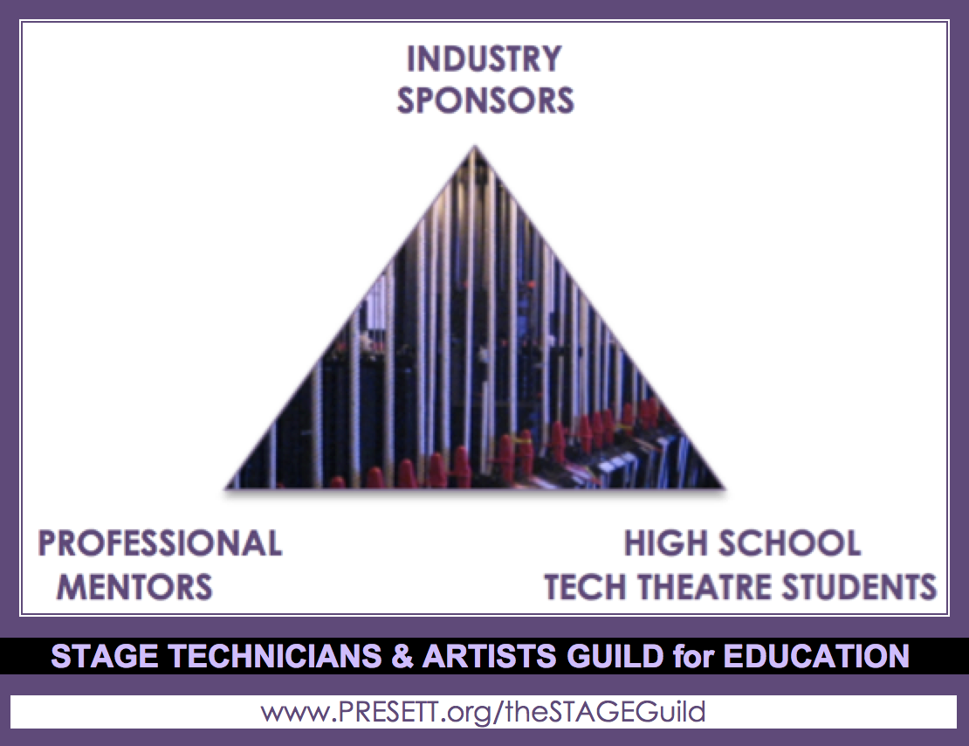
Submit form to: Beth@PRESETT.org

SCHOOL INFORMATION
 | SCHOOL | Type school here
 | CITY, STATE | Type city,state here
 | APPLICANT’S NAME | Type applicant’s name here
 | JOB TITLE | Type applicant’s job title here
 | EMAIL/PHONE | Type applicant’s email/phone here
Please fill out one form per technician/artist per show. You may submit as many forms as you like.

PRODUCTION INFORMATION
 | PLAY OR MUSICAL | Type the title of the play or musical (if chosen)
 | REHEARSAL START DATE | Type the date (approximate is ok) rehearsals will start
 | TECH WEEK START DATE | Type the date (approximate is ok) tech rehearsals will start
 | OPENING NIGHT DATE | Type the date of opening night (if not yet known, type month)
 | CLOSING NIGHT DATE | Type the date of closing night (if not yet known, type month)
 | # OF PERFORMANCES | Type how many performances there will be
 | HOW MANY STUDENTS | Type how many (approximate is ok) students will be involved
 | AUDIENCE SIZE | Type typical audience size you expect for each performance

TECHNICIAN/ARTIST INFORMATION (must have existing technician/artist)
 | TECHNICIAN/ARTIST | Type technician/artist’s name here
 | SPECIALTY | Type theatre technician or artist specialty here
 | EMAIL/PHONE | Type technician/artist’s email/phone here
 | WEBSITE | Type technician/artist’s website address here (if applicable)
 | TIME COMMITMENT | Type here whether they are with your students for the full rehearsal and production run, or tech week(s) only.

HOW WILL YOU RECOGNIZE YOUR SPONSOR:
Complimentary tickets (how many ______)
Tour/meet&greets with vocational crew students
Product demos with your students
“Thank you” recognition in play program
Sponsor ad/logo in play program
Sponsor logo on play t-shirt
Sponsor recognition on website/Facebook page
Sponsor recognition on other media ______________________________
Merchandising opportunities (give aways for your and your students)
Other: ______________________________________________________
Other: ______________________________________________________
Please be as innovative and generous as you can.

